Python Control Statements
Decision making is the most important aspect of almost all the programming languages.
As the name implies, decision making allows us to run a particular block of code for a particular decision.
In python, decision making is performed by the following statements.
- If
- else
- elif
if statement
The if statement is used to test a particular condition and if the condition is true, it executes a block of code known as if-block.
The condition of if statement can be any valid logical expression which can be either evaluated to true or false.
Syntax:
If condition:
statement
statement
- 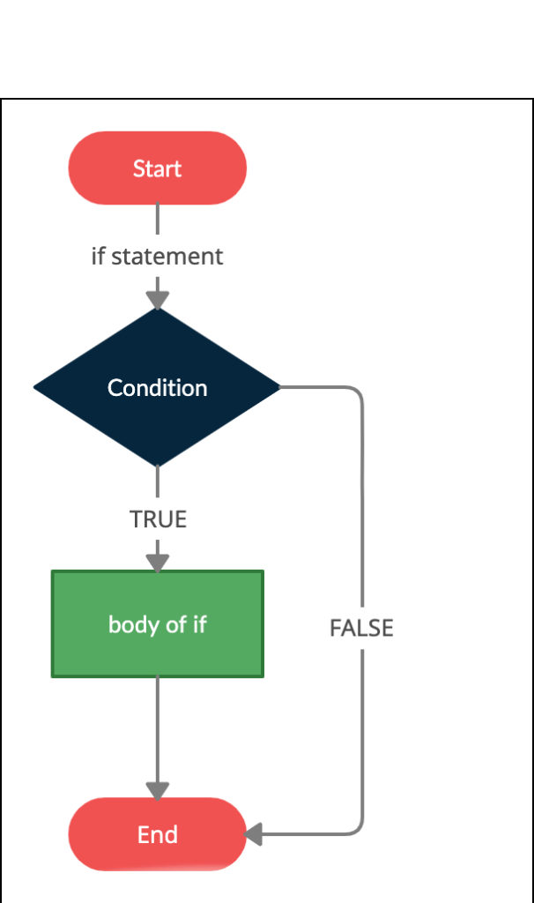

Else statement
The else is an alternate block to the if statement, executes automatically when the if statement returns FALSE.
Syntax:
If condition:
statement
statement
else:
statement
statement

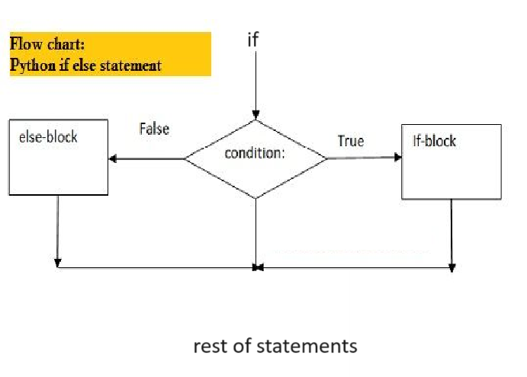

Elif statement
The elif statement enables us to check multiple conditions and execute the specific block of statements depending upon the true condition among them. We can have any number of elif statements in our program depending upon our need. However, using elif is optional.
The elif statement works like an if-else-if ladder statement in C. It must be succeeded by an if statement.
Syntax:
If condition:
statement
statement
elif condition:
statement
statement
elif condition:
statement
statement
else:
statement
statement

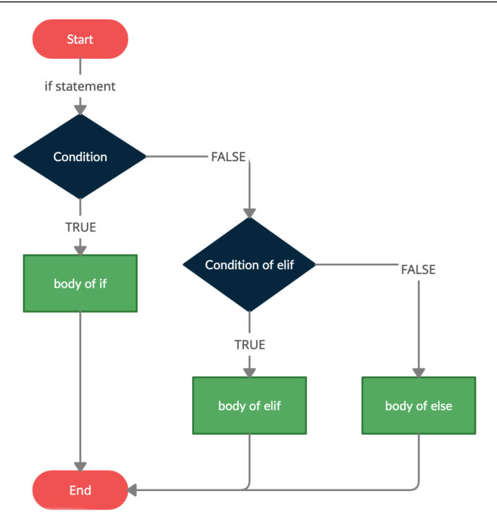

#1. even/odd using if/else only
num = int(input("Enter a Number :"))
if num % 2 == 0:
print(num,'is Even')
else:
print(num,'is Odd')

# 2.finding greatest of 2 Values
a = int(input("Enter a Value :"))
b = int(input("Enter b Value :"))

if a>b:
print("a val %d is Great"%a)
else:
print("b val %d is Great"%b)
#3. finding who can VOTE by checking by their age
age = int(input("Enter Your Age :"))

if age<18:
print("Your'e Minor !")

if age>18:
print("Your'e Major can Vote !")

if age==18:
print("Your'e JUst Reached to Vote !")
Nested If’s
one if condition written in another if known as nested if's

if condition:
if condition:
statement

#4. Finding greatest of 3 Values using nested if’s
a = int(input("Enter a Value :"))
b = int(input("Enter b Value :"))
c = int(input("Enter c Value :"))

if a>b:
if a>c:
print("a val %d is Great"%a)

if b>a:
if b>c:
print("b val %d is Great"%b)

if c>a:
if c>b:
print("c val %d is Great"%c)

# 5. Checking whether entered YEAR Leap or Not
year = int(input("Enter a Year :"))

if year %4 ==0 and year //100 !=0 or year %400 == 0 :
print(year," is Leap !")
else:
print(year," is not Leap !")

